Corpus Christi has a new Communion rail. The rail, purchased from an unnamed NJ Catholic church, was blessed and first used on January 24, 1891, and will be in use at all Traditional Latin Masses here. The following (edited) article appeared on thecatholicthing.org website, and gives a wonderful commentary on the purpose and use of the communion rail:
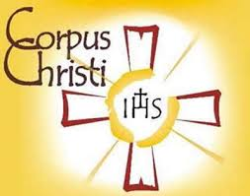 THE INTENTIONAL DISCIPLE
The Evangelization Newsletter of Corpus Christi Parish

“To bring Jesus the Christ to the other in thought, word and deed” …….…………………………………. OCTOBER 2020

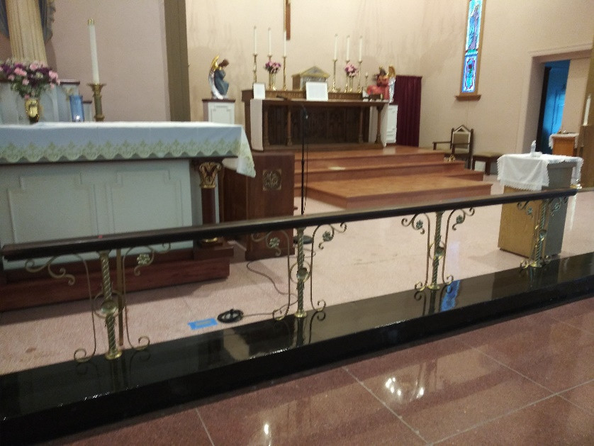
The Communion Rail
By Rev. Jerry J. Pokorsky The traditional Communion rail has functional and sacramental purposes. It distinguishes the sanctuary from the nave and the priest from the people. The architectural logic of the Communion rail symbolizes the sacred (“set apart”) and ministerial priesthood with the priest offering Mass as a mediator in Christ the Head. The priest, as male, images Jesus as the Divine Bridegroom in union with His beloved Church. And he feeds the Bride of Christ at the Communion rail, from the “table of the Lord.” Bride and Bridegroom are distinct but never divorced. Paradoxically and beautifully, the Communion rail invites the people to confidently step up to the very edge of the Holy of Holies in reverence. The Communion rail not only links the priest and faithful, but it is also a beautiful architectural symbol that accentuates the harmonious and complementary relationship between priest and people, between Christ and His Church. *******
________________________________________________________________________

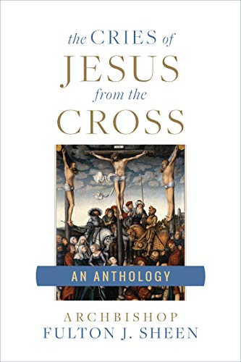
BOOK REVIEW: The Cries of Jesus from the Cross
As death approaches, the human heart speaks its greatest words of love to those it holds most dear. So it was with Jesus who in His final hours gave us seven last "words" rich with spiritual meaning for every human soul. For the first time ever, Archbishop Fulton Sheen's complete writings and reflections on Christ's last words have been compiled into this one book. Sheen shows how the seven words are, in fact, a full catechism on the spiritual life. From them, you'll learn the secrets to living the Beatitudes, ways to avoid the deadly vices of anger, envy, lust, and pride, and how to cultivate the heavenly virtues of fortitude, prudence, justice, and charity. Few books are such an inspiring call to sanctity, and few books are such a spiritual powerhouse. *******

