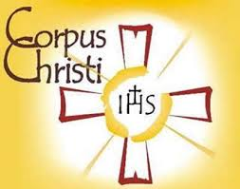 THE INTENTIONAL DISCIPLE
The Evangelization Newsletter of Corpus Christi Parish

“To bring Jesus the Christ to the other in thought, word and deed” ….……………….……………………………………. MAY 2021

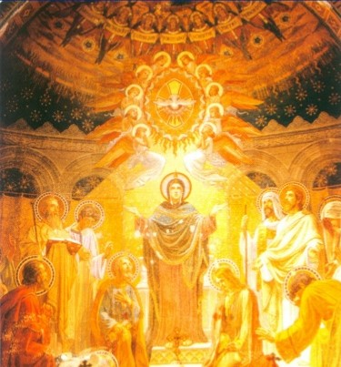
Mary was the first evangelizer when she visited her cousin Elizabeth. The Child Jesus living within her evoked a response of conversion from John the Baptizer in the womb of his own mother (Luke 1:41).
Evangelization requires a personal encounter and ongoing intimate relationship of communion with the Lord Jesus, the Savior born of Mary. "Oh, Jesus living in Mary, come and live in me." This short ejaculatory prayer can be said frequently throughout every day.
We have been constantly reminded that the Church is by nature missionary and that every baptized Christian participates in her missionary activity. Evangelization means taking this truth to heart and living differently. Only a Church fully alive in the Lord and filled with His Spirit can carry out such an evangelical mission.
Mosaic of the Pentecost, Rosary Basilica.
Lourdes, France

Just when her opponents are ready to count the Catholic Church out, the sleeping giant is rising. The Church is Christ's plan for the entire world. Mary is the Mother of the Church, the Mother of the first evangelization and the Mother of the New Evangelization.
This Catholic Church is not a mere human institution. If it were, it would have shipwrecked long ago. The contemporary culture has lost its way, throwing off almost every remnant of Christian influence. It has embraced a new paganism that Pope Francis calls the "Dictatorship of Relativism." Culture has embraced this practical atheism and it is the bad fruit of a rejection of truth.
Given the current state of moral decline we need to view the entirety of the American continent as missionary territory, ripe for the New Evangelization. We need to view the once Christian Nations of the European continent as mission territory.
Most importantly, we need to view ourselves as missionaries in a new missionary age. The Lord of the harvest is calling workers to the New Evangelization of His Church. Then, as loyal sons and daughters of that Church, He is calling us into the fields of contemporary culture which are ripe and ready for harvest. Going before us in prayer and example is the Virgin Mary, the Mother of the New Evangelization. *******

