Lawrence Terlizzese, Corpus Christi parishioner, lector, evangelization ministry member, and author recently published a wonderful new book, Techno Critical Manifesto: Resistance is Freedom (available at your favorite bookseller), and it clearly, and completely guides the reader through the predicament of finding the right spiritual approach to new technologies.
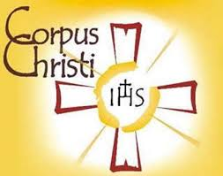 THE INTENTIONAL DISCIPLE
The Evangelization Newsletter of Corpus Christi Parish

“To bring Jesus the Christ to the other in thought, word and deed” ……………….………………………….MARCH 2021

Holding a PH. D. in Theological Studies from Dallas Theological Semenary, this is his fourth publication on the pressing issue of faith and technology.

What the Manifesto is trying to achieve is a new awareness of the technological problem by focusing on responsible technology use. The book is divided into three parts:

Part I raises the problem of developing life-sustaining technology without destroying the earth in the process. “The central ethic of this Manifesto is the reverence for life.”

Part II focuses on a solution to our technical quandry that must come by reason of a spirituality that transends the system.

In Part III, the author makes the case for critical self reflection on those technological restraints we have no control over.
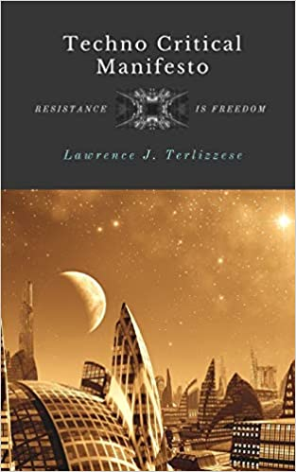

“There must be denial before affirmation, law before grace, crucifixion before resurrection.”

“If we cannot say no to technilogical addiction, even in the smallest degree, we are not free.”

“Society must recognize limits to these practices (nuclear power, artificial intelligence, and genetic engineering) if we expect to bequeath a future to our children’s children.” *******

Here are a few samples of the wisdom to be found on every page:

“There are no technological solutions to technical problems—we are the solution.”

“Resistance is freedom means that in light of the pull by technologism to universal conformity, there remains a space, however small, for freedom.”

