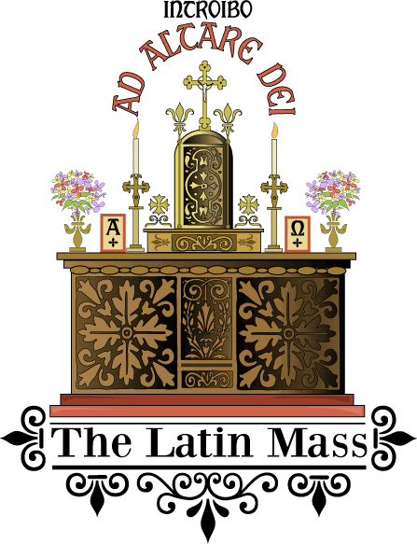
Corpus Christi Latin Mass Society
CORPUS CHRISTI LATIN MASS SOCIETY Schedule (please check weekly Bulletin):
Wednesdays 6:15 PM, First Fridays 7:00 PM, First Saturdays 12 Noon, and Sundays 3:00 PM
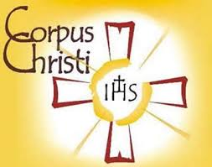 THE INTENTIONAL DISCIPLE
The Evangelization Newsletter of Corpus Christi Parish

“To bring Jesus the Christ to the other in thought, word and deed” ……………….……………………………. JULY 2021

Marks Its Second Anniversary
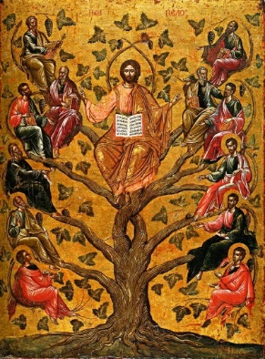
The Corpus Christi Latin Mass Society celebrated the Feast of the Sacred Heart of Jesus on Friday June 11 marking the second anniversary of Mass in the extraordinary form at Corpus Christi. Father Damian was very pleased at the growth in attendance and praised the Latin Mass attendees for their outstanding devotion. Father's love for the Sacred Heart of Jesus inspired him to bring the Tridentine Mass here with the hope that parishioners would be evangelized through the beauty of the liturgy. Refreshments were served after Mass. *******
On Being In, not Of, the World
David G. Bonagura Jr. – thecatholicthing.org
(Image: Christ, the True Vine)
“Be in the world, not of it.” So, Catholics are called to live – engaged in worldly affairs, but not shaped by them. Jesus refers to “the world” as a spiritual force that is inherently at odds with Him and His mission. Christ's goal is to transform us to be less like the world and more like Him. Modernity has embraced “the world” as its god, a consequence of its repudiation of the things that are above. With this fatal shift has come the absorption of many Catholics into “the world” so that there is seemingly little difference between them and everyone else in terms of how they live. We need a Biblical response in order to restore the things of God to first place and to recognize “the world” for what it is – forces that keep us from God. Ideas and practices that contradict the Bible must be condemned as evil, no matter how popular they may seem. We must constantly render thanks for all the good things we enjoy in life – faith, family, sports, leisure, technology, art, literature – for what they truly are: gifts from God. Finally, we must always keep in mind Our Lord's words, “In this world you will have trouble. But take heart! I have overcome the world.” (John 16:33) *******

