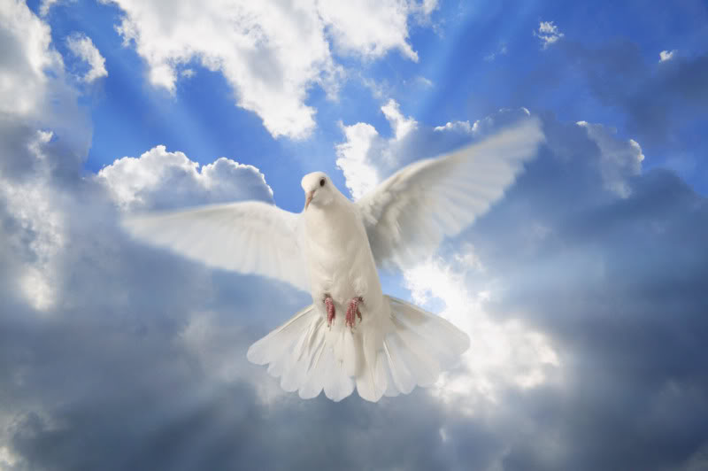

Confirmed with Holy Spirit – November 21, 2020

Tiago Capela Joshua Oliveira
Emily Castro Daniella Peixoto
Diego dos Santos Ashley Pereira
Matthew Gonzalez Rafael Ribeiro
Nicole Lopez Goncalo Teco
Sara Moderno Kelly Vaz
Briana Nogueira Matthew Velez

