
First Sunday of Advent
Saturday, November 30
5:00 p.m. Vigil Mass
+ Michael Gahrmann
Sunday, December 1
8:30 a.m. +David Campos, Sr.
10:00 a.m. +Steven Requena
5:00 p.m. People of the Parish
Monday, December 2
7:30 a.m. +Memorial Society
Tuesday, December 3
7:30 a.m. +Thomas S. Gahrmann
Wednesday, December 4
St. Peter Chrysologus, Bishop,
Confessor,& Doctor
6:15 p.m.* +Mario Rodrigues
+Helena Suvtil
Thursday, December 5
7:30 a.m. +Mary T. Hauser
Friday, December 6
Sacred Heart of Jesus
7:30 a.m. +Catherine Cantasano
7:00 p.m. Low Mass
Saturday, December 7
Immaculate Heart of Mary
12:00 a.m. Low Mass
5:00 p.m. Vigil Mass
+ Mary Clayton
Sunday, December 8
Second Sunday of Advent
8:30 a.m. People of the Parish
10:00 a.m. +Edwin C. Kolakowski
5:00 p.m. +Margaret Drum
*Extraordinary Form
Pope Francis’ Prayer Intention for December
UNIVERSAL –
The Very Young
That every country resolutely commits to taking the necessary measures to make the future of the very young, especially those who suffer, a priority.

Stewardship – Time, Talent & Treasure

Collection amounts were not available at the time the bulletin was sent to print. All collection amounts will be listed in next week’s bulletin.

Please remember Corpus Christi Parish
in your will and estate planning.
Advent Penance Service
Friday, December 13, 2019 6:30 p.m.
Several priests will be available to hear confessions.

Week of November 30- December 6

MEMORIAL AND SPECIAL INTENTIONS

+ Sacred Heart+
Special Intention

Roger Gregor, Janice Gowen, Stanley Pich,
Phyllis Mason, Florence Unverzagt,
Maria C Silva, Jean Obst, Luke Mayell,
Patricia Ronan, Margaret Drack,
Bernadette Haase, Suzanne Boyce,
John Gregor, Basilda Barbosa Fernandes,
Karen Kleinschmidt, Josephine Dehlinger, Kristin Rein,
Peggy Reynolds, Helen Kovacs, Carol Ostrowski,
Gloria Gregor-Hughes, Ines LuSoto, Joyce Hanula,
Emerson Harper, Joan Petersen, Susan Wiecek Shecter,
Rebecca Rannazzisi, Louis Kadubic, Renee Giliberti,
Debbie Canuso-Danley, Judi Zyskowski, Samuel Saloom,Jr,
Kathleen McGreevy, Michael Majewski, Noel Gowran.
Please keep us updated on your loved ones.
December 1, 2019
The First Sunday of Advent
“…Therefore, stay awake! For you do not know on which day your Lord will come.” (Matthew 24:42)
People who have had health issues or near-death experiences generally have a greater appreciation for each day being a gift from God. The rest of us usually take for granted that we will be around tomorrow. But when you start to look at each day as a gift, you realize all the little miracles that happen daily and grow in gratitude for all that we have been given. You begin to see God’s active presence in your life.


Phew! This year’s ITF is under the belt! I want to thank all of you for the time and energy you put into making it such a great success. It would not have been possible without the many hands, heads and hearts that made such an effort to make this event so special. Your commitment is truly appreciated.
Allegra Gerlach
We want to thank Allegra, Gerry & Rachel for all that they did in organizing, decorating and preparing some of the delicious food and making this year’s International Thanksgiving a wonderful event. Plenty of food, prizes, and warmth was felt throughout the evening. Many thanks to you and your committee members for working so hard.

The Saint Vincent de Paul Society, with the Portuguese Social Ministry, is sponsoring a Christmas Wish Tree. All parishioners are invited to participate. Please take an ornament from one of the trees and purchase a gift card. Mark the amount on the cards and place them in the collection basket, or deliver them to the Parish Office. These cards will be delivered to the families who have been helped this year.
Corpus Christi Church 3rd Annual Holiday Cookie Walk

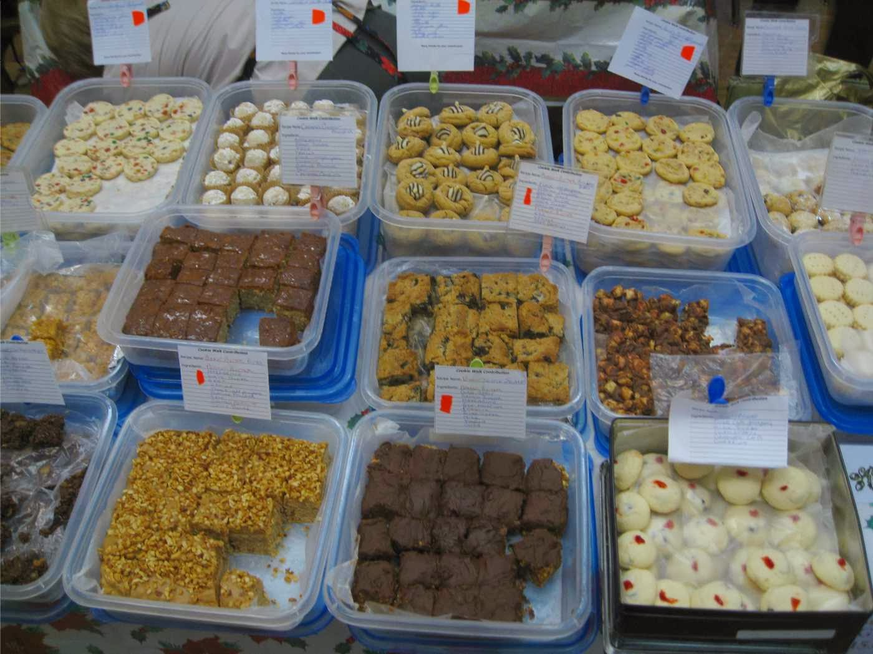
Sunday December 8th starting at 11am. Come to the Church Hall, take a bakery box and fill it with homemade cookies, cakes, etc. The cost is $8.00 per pound. For more information call, Eliana 732-770-8245, Ann 732-589-1576 or Pam 732-921-0307. SAVE THE DATES - Children’s Holiday Extravaganza Sat. Dec. 14th 11am-2pm
Raymour & Flanigan Midstate Mall
Children’s Movie Night Out“ Wonder”
Friday Dec. 20th 7-9:30pm Corpus Christi Church Hall
First Saturday – December 7, 2019
Confessions 11:00-11:30 a.m.
12 Noon Low Mass (Extraordinary Form)

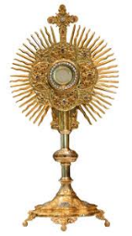
First Friday Devotion to the Sacred
Heart of Jesus – December 7, 2019
3:00-6:45 p.m. followed by Benediction
An excellent practice recommended by all the saints, especially St. Margaret Mary Alacoque, (1647-1690) Is devotion to Jesus in the Most Blessed Sacrament in which through our prayer in silent adoration we make reparation to the Sacred Heart of Jesus for the sins which have offended God in this world mocking our Savior and His great goodness and love. If possible, for 9 consecutive months attend Mass on First Friday, receiving Holy Communion. If in need of the Sacrament of Penance receive it as well. It has been the time-honored practice as well to make a holy hour before Jesus in the Most Holy Eucharist on First Friday of the month which is observed here at the parish church from 3pm-6:45 pm followed by Benediction. Confession at 6:00-6:30p.m, Low Mass 7:00pm. All parishioners are invited to offer a minimum of 7 minutes of prayer for the intention of Evangelization, please consider the Lord’s merciful invitation to pray and rest in Him, “I am deeply grieved, even to death, remain here, and stay awake with me (Matt 26:38).” St. Margaret Mary has said,
“The divine heart of Jesus is an abyss of all blessings, and into it the poor should always submerge”
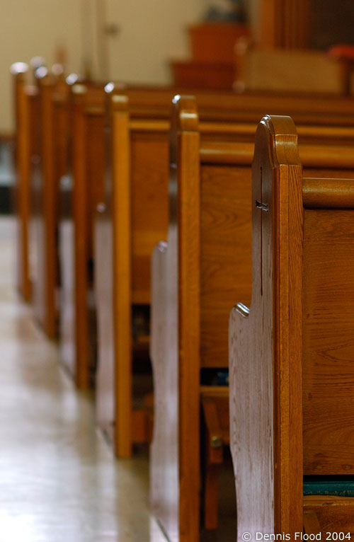
MEMORIALIZING PEWS – For those who have already submitted names and designated pews, a written confirmation on the exact spelling, (wording) as well as location of the pew will be sent to you within the next few weeks. If you have not yet made arrangements for a pew but are considering it, whether a family name or In Memory of a Loved One, call the parish office to sign up or for more information. Donation is $500.00. Please note you may wish to make installment payments.
December 8 – Holiday Concert
The Imperial Music Center, 48 Appleby Ave., South River will present its usual monthly concert. A lite lunch is available for purchase 12-2 pm, concert starts at 2pm, conductor Joe Walter. A $5 donation is appreciated. For information call 732-238-0310 or visit www.thimperialmusticcenter.com

