

The Nativity of the Lord
Saturday, December 24
Vigil Mass
4:00 p.m. Christmas Remembrance of Masses
10:30 p.m. Christmas Remembrance of Masses
Sunday, December 25
Christmas Day
8:30 a.m. Christmas Remembrance of Masses
10:00 a.m. Christmas Remembrance of Masses
Monday, December 26
St. Stephen
9:00 a.m. +Carlo Riello
Tuesday, December 27
Saint John, Apostle & Evangelist
7:30 a.m. +Richard Holliday
Wednesday, December 28
The Holy Innocents
5:00 p.m. +Rossi-Certo Families
Thursday December 29
7:30 a.m. +David Jamena
Friday, December 30
The Holy Family of Jesus, Mary & Joseph
7:30 a.m. +Josefa S. Jamena
Solemnity of Mary, The Holy Mother of God
Saturday, December 31
Vigil Mass
5:00 p.m. +Mary T. Hauser
Sunday, January 1
8:30 a.m. +Joseph Mancuso
10:00 a.m. +Joseph Popovich
5:00 p.m. People of the Parish



MEMORIAL AND SPECIAL INTENTIONS
+Altar Candles+
Edwin Kolakowski

+Candle for Mary+
Special Intention

+Sanctuary Candle+
Thomas J Noto

+Bread & Wine+
Mastandrea & Maestripieri Families
Offerings are available for a loved one or special intention for living members for $25.00 a week.

If you have added someone to the Prayer List, please keep us posted on their condition so that our list will be updated.
Joyce Hanula, Helen Kovacs, Kristin Rein,
Rita Payor, Susan Wiecek Shecter, Margaret Drack,
Cheryl Hayes, Maria Rossi, Florence Unverzagt, Helen Plank,
Antoinette Rossi, Patricia Doyle, Karen Kleinschmidt,
Josephine Dehlinger, Herb Fialia, Carol Ostrowski,
Marilyn Rinfret, Patricia Ronan, Genevieve Mroczko, Peggy Reynolds,
Kathleen McGreevy, Renee Giliberti, Noel Gowran, Marie Bodnar,
Rebecca Rannazzisi, Mary Ann Laskoski, Debbie Canuso-Danley,
Fr. Kevin Casey, Phyllis Mason, Catherine Nugent, Fran Wlazlowski

Stewardship – Time, Talent & Treasure

Collection for December 18 - $ 7,093.00
Mail Collection $ 935.00
Total Plate Collection $8,028.00

Please remember Corpus Christi Parish
in your will and estate planning.

Christmas Remembrance & Flower envelopes may be
dropped in any collection basket or at the parish office.
We welcome all who worship or want to stop in at any time to pray in our church. Our church is open Monday, Tuesday, Thursday, Friday 6:00 a.m.–6:00 p.m.
(First Friday 8:30 p.m.)Wednesday 6:00 a.m.-8:30 p.m.
Saturday (last Mass 7:30p.m.) and Sunday (5:00 p.m.) the church will close following the Masses.
The Parish Office hours are Monday-Thursday 9:00 a.m.-4:00 p.m. Fridays 9:00 a.m. 2:00 p.m.

The Parish Office will be closed on Monday, December 26th and re-open on Tuesday, December 27th at 9:00 a.m.
Please note Mass will be celebrated at 9:00 a.m. on Monday, December 26th.

Wednesday December 28, 2016
5:00 p.m. Mass – Anointing of the Sick
(last Wednesday of every month)


Forming your Faith…….. We are excited to announce that Corpus Christi Church has become a partner in an exciting 24/7 on-line web-based digital formation series called FORMED, produced by the Augustine Institute and Iganatius Press. This series is designed to help adults grow in their faith at all levels – how we think, how we pray, and how we live. Better yet, access is FREE to all of our parishioners and their families anywhere, anytime on computers, tablets, or phones. Register free using our Parish Code ZD3P77.
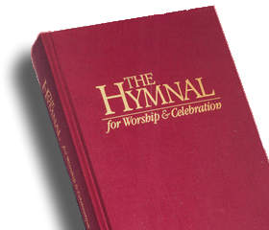
Saint Augustine Hymnal - It’s not too late to donate a hymnal In Memory of a Loved One or just having a family name in the book.
Any parishioner who would like to consider donating a hymnal as a memorial gift, for the cost of $25 per book, please call the parish office. A name plate will be placed in the front cover of the hymnal, dedicating the book to the prayerful memory of your loved one. Forms are available in the church or at the parish office.

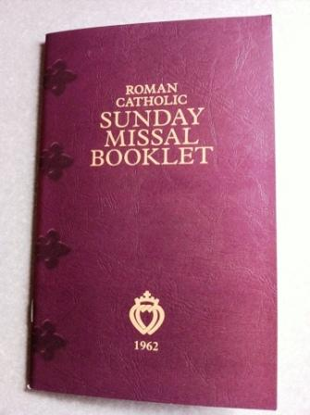
The Parish Office has a few 2017 Saint Joseph Sunday Missals available if anyone is interested for $4.00.


God Bless You! We appreciate your support for our Religious and Charitable Works. Quick Code for IMMEDIATE DONATIONS. Help us Preserve Our Blessings and Our Church
◄SCAN THIS CODE & DONATE NOW!
Use your phone or tablet to scan the Corpus Christi Code. On-line Giving Code for your weekly or monthly support.
Please note at any time, you may begin ON LINE GIVING by logging on to our website: Or use the Corpus Christi Quick Code for Immediate Donations. See Quick Code info on next page of bulletin.
ON LINE GIVING Our thanks to the many families that have signed up for Online Giving! If you manage your bills online, we’re sure you’ll like the convenience of giving to your parish online. It’s safe and secure, and you decide exactly when your gift is made. You may even view your giving history just by logging in Visit our website: www.corpuschristisouthriver.org – and get started

Corpus Christi has a new Envelope Company for those parishioners who are receiving weekly envelopes. Beginning January, 2017, your envelope packets will now be coming from Our Sunday Visitor no longer Cathedral Corporation. They are more cost efficient for the parish. If you end up
with two envelopes for January 1, 2017, either one may be used.
You Can Save Your Marriage!
Retrouvaille – A lifeline for troubled marriages
Has your marriage become unloving or uncaring – your relationship grown cold, distant – thinking about a separation or divorce? Are you already separated/divorced but (both of you) wish to try again – then the Retrouvaille program may help you.
RETROUVAILLE (Rediscovery) sponsored by the Family Life Office/Diocese of Metuchen consists of a weekend experience for couples (no group discussions) with six follow-up sessions.
The next program is scheduled for the weekend of February 10-12, 2017. All inquiries are confidential. For more details please call the Family Life Office 732-243-4573. Rich & Annette Colasuonno 732-236-0671 or Tome & Pat McTague 732-583-4468 (evenings).
St. Thomas the Apostle Thrift Store needs winter coats and clothing. Located at 1119 Englishtown Rd. in Old Bridge offers new and gently used items for sale at very reasonable prices. With the cold weather here, we are now in need of winter coats and clothing for men, women and children – especially children. New and gently used donations of coats as well as men’s, women’s and children’s winter clothing, shoes/boots, as well as blankets/linens, household items and toys are always appreciated. Donations may be dropped off during store hours: Tuesday, Thursday and Friday from 10am to 2pm, and Saturday from 10am to 1pm. For more info call the store at 732-251-5285.
Are you suffering after an Abortion? Help is available!
If you or someone you know is suffering after an abortion, confidential, non-judgmental help is available. Experience God’s merciful love and begin the journey of healing:
Call Project Rachel’s local toll-free helpline number: 877-877-4300, or Visit HopeAfterAbortion.org. Spanish-speakers may visit EsperanzaPosaborto.org. Or call Sisters of Life at 866-575-0075 or email hopeanhealing@sistersoflife.org

Merry Christmas & Happy New Year
from Fr. Damian and the Parish Staff
(Clancy too)

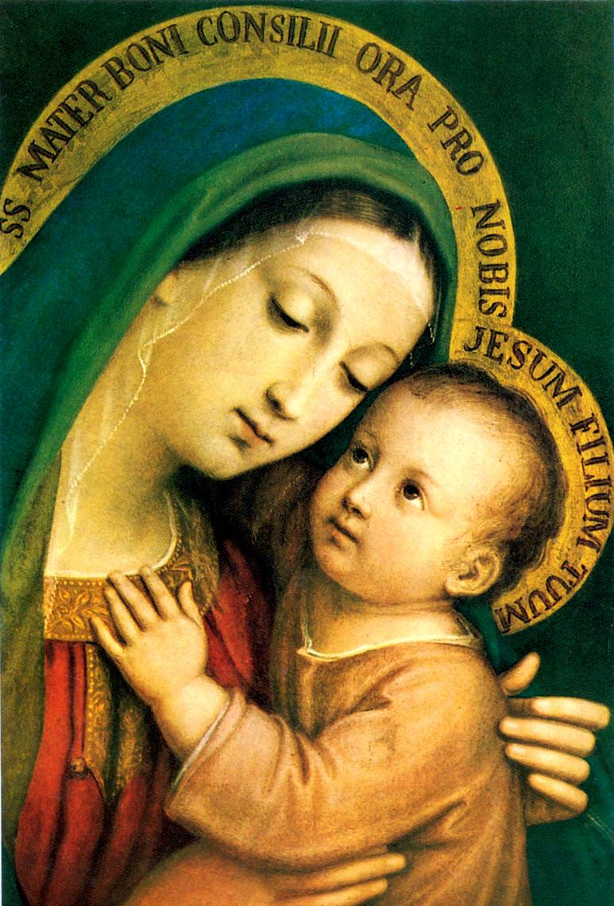
Solemnity of Mary, Holy Mother of God
Saturday, December 31, 2017
5:00 p.m. Mass
7:30 p.m. Mass Portuguese
Sunday, January 1, 2017
8:30 a.m. & 10:00 a.m. Masses
11:30 a.m. Portuguese Mass
5:00 p.m. Mass
Monday, January 2, 2017
9:00 a.m. Memorial Society
The Parish Office will be closed on Monday, January 2nd and re-open on Tuesday, January 3, 2017.
Many thanks for all who have supported our Lucky Calendar. We had a tremendous year and hopefully 2017 will be even better with your support.

*Please consider supporting our parish in purchasing the buy two get one free special! Perhaps you can offer them to people outside the parish if you cannot purchase the two. This is our sole big fundraiser for the parish. Our profit doubled from the previous year selling them this way. The calendars make great year-round gifts. Extra calendars are available at the parish office during regular office hours. Remember to return your entries before the first drawing date; Tuesday, January 3, 2017 1:00 p.m. in the parish office.
Spanish Speaking Deacon Recruiting is now Underway
The Diocese is looking for faith-filled Spanish-speaking men who are interested in becoming Permanent Deacons. A General Information meeting will take place at the St. John Neuman Pastoral Center in Piscataway in January, 2017. If you believe you are being called to this ministry, contact the parish office and we will recommend you to the Diocesan Diaconate Office.
Catholic Charities is seeking volunteer mentors – Both male and female mentors are needed to participate in one-to-one activities and be a role model to young people.
Do you;
- Have a minimum of three hours per week to offer a child?
- Like having fun?
- Reside in or near Middlesex County or Franklin Township?
- Want to make a difference in a child’s life?
Contact Jeanette Cullen at (732) 738-1323 or jcullen@ccdom.org, for more information.
Christmas Shopping Prayer
Lord, in the crush and rush
of Christmas shopping,
stop me every once and a while
and remind me that I’m doing
all this out of love.
You give me the gift of yourself
at Christmas;
I’m giving these Christmas gifts of love
to all these wonderful people gifts
you have placed
under the tree of my life. Amen Andrew Costello

