

Our Lord Jesus Christ, King of the Universe
Saturday, November 19
Vigil Mass
5:00 p.m. +Walter Schmitt
Sunday, November 20
8:30 a.m. +Barbara Popovich
10:00 a.m. +Elizabeth Addae
5:00 p.m. People of the Parish
Monday, November 21
Presentation of the Blessed Virgin Mary
7:30 a.m. +William Lupinacci
Tuesday, November 22
St. Cecilia
7:30 a.m. +William M. Lang
Wednesday, November 23
5:00 p.m. +Mass of Thanksgiving
Thanksgiving Day
Thursday November 24
Saint Andrew
9:00 a.m. +Michael & David Gahrmann
Friday, November 25
9:00 a.m. +Steven Requena
First Sunday of Advent
Saturday, November 26
Vigil Mass
5:00 p.m. +The Humeniuk Family
Sunday, November 27
8:30 a.m. People of the Parish
10:00 a.m. +Louis Kosa
5:00 p.m. +Primitivo Beltran


MEMORIAL AND SPECIAL INTENTIONS

+Bread & Wine+
Michael & David Gahrmann

+Candle for Mary+
Special Intention

+Sanctuary Candle+
Michael & David Gahrmann

Offerings are available for a loved one or special intention for living members for $25.00 a week.

If you have added someone to the Prayer List, please keep us posted on their condition so that our list will be updated.

Joyce Hanula, Helen Kovacs, Kristin Rein,Rita Payor,
Susan Wiecek Shecter, Margaret Drack, Cheryl Hayes, Maria Rossi,
Antoinette Rossi, Florence Unverzagt, Helen Plank, Patricia Doyle,
Karen Kleinschmidt, Josephine Dehlinger, Caryn Guskind, Herb Fialia,
Marilyn Rinfret, Patricia Ronan, Genevieve Mroczko, Peggy Reynolds,
Melanie Michelle, Kathleen McGreevy, Renee Giliberti,
Rebecca Rannazzisi, Mary Ann Laskoski, Debbie Canuso-Danley,
Fr. Kevin Casey, Phyllis Mason, Catherine Nugent,
Carol Ostrowski, Fran Wlazlowski, Marie Bodnar.

Stewardship – Time, Talent & Treasure

Stewardship – Time, Talent & Treasure
Collection for November 13 - $ 6,339.50
Mail Collection $ 797.00
Total Plate Collection $ 7,136.50

Archdiocese for Military $1,792.00

Please remember Corpus Christi Parish
in your will and estate planning.
We welcome all who worship or want to stop in at any time to pray in our church. Our church is open Monday, Tuesday, Thursday, Friday 6:00 a.m.–6:00 p.m.
(First Friday 8:30 p.m.)Wednesday 6:00 a.m.-8:30 p.m.
Saturday (last Mass 7:30p.m.) and Sunday (5:00 p.m.) the church will close following the Masses.
The Parish Office hours are Monday-Thursday 9:00 a.m.-4:00 p.m. Fridays 9:00 a.m. 2:00 p.m.
The 2017 Mass Book is now open for Mass Intentions. Intentions are also being taken for Candle for Mary, Sanctuary Candle, Altar Candles, the Gifts of Bread & Wine and also Altar Flowers any given week that you choose. Stop in at the parish office during regular hours. Multiple Intentions may be taken on Wednesday evenings at 5:00 p.m. Mass.
Feast of Our Lord Jesus Christ, King of the Universe
November 20, 2016
“…giving thanks to the Father, who has made you fit to share in the inheritance of the holy ones in light.” Colossians 1:12
God wants us to be happy! Instead of looking at the Ten Commandments as being restrictive and telling us what we can’t do, look at them as guides for living a joy-filled and peaceful life. Most of our problems arise when we put our own needs first or spend most of our time trying to acquire “things”. Try putting God first in all things instead.
Please note: Communal Anointing of the Sick during the 5:00 p.m. Mass for the last Wednesday of the month has been moved to this Wednesday, November 23rd due to the Parish Mission next week.
New Saint Augustine Hymnal
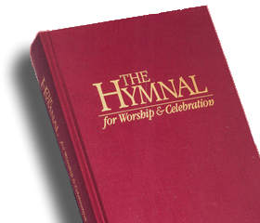
Any parishioner who would like to consider donating a hymnal as a memorial gift, for the cost of $25 per book, please call the parish office. A name plate will be placed in the front cover of the hymnal, dedicating the book to the prayerful memory of your loved one. Forms are available on the table in the church located by the Baptismal Font. Forms may be filled out and dropped off at the parish office.
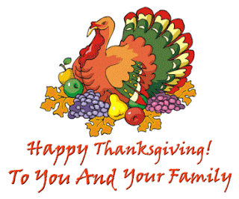

The Parish Office will be closed on Thursday and Friday for the Thanksgiving Holiday. The office will re-open on Monday, November 28th at 9:00 a.m.


God Bless You! We appreciate your support for our Religious and Charitable Works. Quick Code for IMMEDIATE DONATIONS. Help us Preserve Our Blessings and Our Church
◄SCAN THIS CODE & DONATE NOW!
Use your phone or tablet to scan the Corpus Christi Code. On-line Giving Code for your weekly or monthly support.
Please note at any time, you may begin ON LINE GIVING by logging on to our website: Or use the Corpus Christi Quick Code for Immediate Donations. See Quick Code info on next page of bulletin.
ON LINE GIVING Our thanks to the many families that have signed up for Online Giving! If you manage your bills online, we’re sure you’ll like the convenience of giving to your parish online. It’s safe and secure, and you decide exactly when your gift is made. You may even view your giving history just by logging in Visit our website: www.corpuschristisouthriver.org – and get started

Youth Group Homeless Baskets
The youth group will once again be collecting items to create baskets for the homeless residing at the Ozonam Shelter in New Brunswick. We will be filling our baskets with the following items: Pens, pencils, crayons, notebooks, socks, mittens/gloves, hats, individually wrapped candy, and travel size toiletries. Toiletries include: small packs of tissues, bar soap, shampoo, conditioner, deodorant, razors and shaving cream, hand wipes, mouth wash, toothpaste and toothbrush, hair comb and paper bags (approximately 12”x12” in size) to put all the items in. If you would like to assist us, please feel free to drop any of these items in the box in the back of the church. Monetary donations will also be greatly appreciated, and can be left in the parish office. We are looking to make a total of 30 bags. Thank you in advance for your support.
East Brunswick Vo-Tech School “Supporting the Artists of the Future”
Friday, December 2nd , 7:00p.m.-9:00p.m. at Corpus Christi Church Hall. $30.00 includes painting, easels, paints, brushes and 1 cupcake per person.
St. Lawrence Altar Rosary Society will hold their annual Tricky Tray on December 4th in the Parish Hall, Laurence Parkway, Laurence Harbor. Doors will open at 12:30, calling will start at 2:00 p.m. Refreshments will be available for purchase. The event will feature many prizes, including gift certificates, theme baskets, electronics, designer bags, TV and more. Tickets are $10 and include two cards. NO ONE UNDER 18 will be admitted. For additional information, call Maria at 732-290-3002 or Karen at 732-727-3774.
Our Lady of Victories Parish, Sayreville, will hold a Mass and healing service on Monday, December 5th at 7:00 p.m. The celebrant will be Father John Campoli, Director of His Love Ministries. Individual healing prayers will be given following Mass.

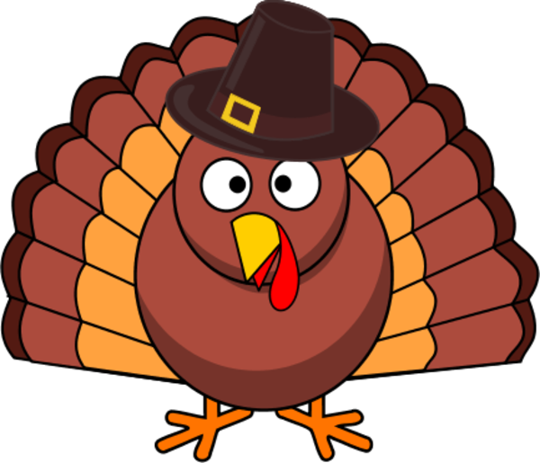
The South River Food Bank –
Thanksgiving Dinner 2016
The South River Food Bank in partnership with the Ria Mar Restaurant & Bar, Green Construction, and Sts. Peter & Paul Church will be hosting a Thanksgiving Dinner!
If you live in South River and are in need of a hot cooked Thanksgiving meal for you and your family, then join us between 12:30 and 2:30 p.m. on Thursday, November 24th at Sts. Peter & Paul Church, 9 Jeffrie Ave., South River – Dinner will be served at 1:00 p.m.

Corpus Christi Church
“Living and Sharing the Gospel
An Advent Parish Mission
Conducted by Good News International
A Catholic lay ministry - Bill Wegner
Sunday. Nov. 27th 7:00 p.m.-Wed. Nov. 30th & after 7:30 a.m Mass.
The thrust of the mission is to bring us into a closer walk with Our Lord Jesus.
It’s almost here!! It won’t be long now, next Sunday November 27th thru November 30th. Our parish mission is almost here. Just 2 weeks away! It will truly be a time of renewal and rejoicing for our community. Don’t let these 4 days pass you by and leave you saying, “I wish I had been there”. If you haven’t made your plans yet, do it right now! Stop whatever you’re doing and put it in your calendar!
And remember, bring a friend!

Christmas Grave Cover and Door Wreath Sale
Once again we will be selling the freshest grave covers and door wreaths decorated beautifully for the Holiday Season. Orders will accepted thru Tuesday, November 29th. These will be available to be picked up Friday, December 2nd a.m. or after the weekend Masses December 3 - 4th. All proceeds will benefit the youth ministry. Forms with prices are available at the exits of the church.
Samples for you to view are outside the back of the church this weekend.
Second Collection this weekend – November 20, 2016
Catholic Campaign for Human Development funds programs in communities across the United States. By giving a hand up, rather than a handout, CCHD helps people living in poverty join together to identify problems, make decisions, and find ways to improve their lives and neighborhoods. Your support helps to end poverty through building solidarity in our communities. Thank you in advance for your support!
St. Mary’s Moms Group: Come Join “Teas & Tots” – Moms of all ages and stages are welcome to join us for coffee/tea, food, faith and fellowship! We will shape the agenda according to your needs. The group is designed to support and affirm women in the many roles that we have in life as mothers, wives, daughters, sisters, and friends. Each month we will present various topics on the role of motherhood and faith formation for our children in a positive and supportive atmosphere. We will have speakers as well as discussion time on the important vocation of raising children of every age. Expectant mothers and those with young children are especially encouraged, but we also need the advice of your experienced moms! Next meeting Thursday, November 17th from 4-5pm in the Children’s Room (downstairs, below the church, across from the bathrooms). Bring ideas (and your little ones!). Contact Agnes 732-447-7074 or Amy at 732-322-4527 for more information.

You should have received your lucky calendar for 2017 in the mail. Please consider supporting our parish in purchasing the buy two get one free special! Perhaps you can offer them to people outside the parish if you cannot purchase the two. This is our sole big fundraiser for the parish. Our profit doubled from the previous year selling them this way. The calendars make great year-round gifts, as well as Christmas stocking stuffers. Thank you for your support of our 2016 Calendar and hopefully we will bring in even more money this year!
Congratulations to Rosa Rocha, the lucky winner for the November 8th drawing. There are still 2 more chances of winning for 2016. One for $500.00 and the last one for $1,000.00. Good Luck to All!

